 | Respect | Resilience | Empathy
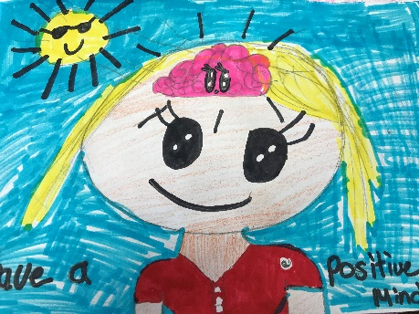  Classroom | Listen to instructions  Concentrate on your work.  Show good manners. | Accept the consequences of your behaviours  Challenge yourself  Have a positive mindset | Put yourself in other’s shoes  Be positive leaders  Celebrate uniqueness of all people
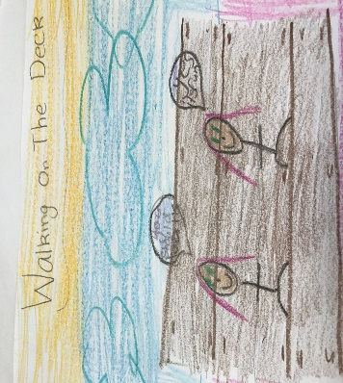  Moving around the school | Give personal space  Walk on the deck  Respect property and belongings | If you fall over pick yourself up | Help others
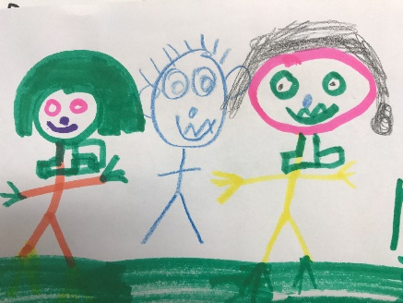  Playground | Own your own behaviour  Hands off policy  Play by the rules | Use the 4 steps: Ignore, Ask them to stop. Walk away, Tell a teacher.  Bounce back | Be inclusive  Help people if they are hurt  Play safely
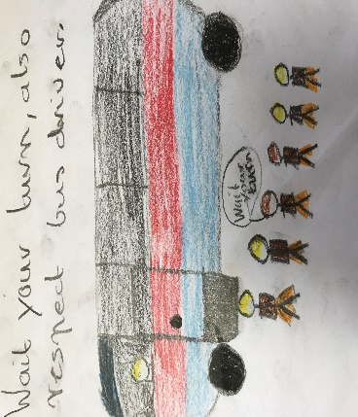  Bus | Follow bus instructions  Wait your turn  Talk politely and quietly to person next to you | Own your behaviour  Wait patiently | Be considerate of other people’s needs  Keep bus clean and aisle clear
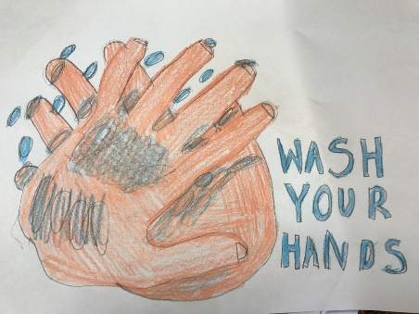  Toilets | Respect privacy  Use toilets appropriately  Use soap and wipe your hands and turn taps off | Own your behaviour | Be considerate to other people using the toilets
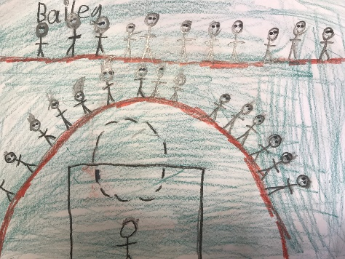  Assembly | Stand quietly and listen the speaker  Sing or stand respectfully for the anthem | Be supportive of other’s achievement  Be sensible and safe  Ignore poor behaviour | Be understanding of other people’s beliefs  Be happy for other people
Swan Reach P.S. School-Wide Expectations

